Running out of money before you run out of month?

Having to decide whether you’re buying laundry soap or dish soap this month? Or having to choose between deodorant and shampoo?

The PEPartnership understands how important personal and household hygiene products are, and is working to make these products more visible as necessities to the community at large and to policy makers, and to improve their availability to people in need. We’re particularly interested in making these products available on a more reliable basis so that you can better plan your budget and expenditures to make best use of the resources you have available.

To help with product availability, all PEPartnership agencies are using the PEPbase software to both standardize what products are available, and to ensure that, while everyone can have what they need, no one can over-use the system.

The chart below shows the products offered at each agency. See the PEPartnership Agencies listing (on the other side of this brochure) for explanation of the Agency Key.

Agency Key | A | C | St | GN | I | GE
all purpose cleaner |  |  | x | x | x
baby wipes |  |  | x | x |  | x
band-aids |  |  |  |  | x
comb |  |  | x
conditioner |  |  | x |  |  | x
dental floss |  |  | x |  | x
deodorant | x | x | x | x | x | x
diapers / pull ups | x |  | x | x |  | x
dish soap | x | x | x | x | x | x
Incontinence pads |  |  |  | x | x
kleenex |  |  | x |  | x
laundry soap | x |  | x | x | x | x
Q-tips |  |  | x |  | x
razors | x | x | x | x | x | x
shampoo | x | x | x | x | x | x
body soap | x | x | x | x | x | x
tampons | x |  | x | x | x | x
toilet paper | x | x | x | x | x | x
toothbrush | x | x | x | x | x | x
toothpaste | x | x | x | x | x | x

How the PEPartnership works

All of the PEPartnership agencies provide products for personal and household hygiene. You’re invited to use any of the PEPartnership agencies (check each agency’s website for full eligibility requirements, if any). Products are distributed based on household composition and product lifespan across all PEPartnership agencies.

Each time you shop at a PEPartnership agency, you will receive a shopping list of all available products that your family is eligible to request at that visit.

You then check off the items from the list that your family currently needs, and volunteers will fill your order for you.

That means you can shop at any or all of the PEPartnership agencies to get the products you need, without having to re- register and answer the same set of questions each time.

Over time, we hope to have PEPartnership agencies across Madison and into greater Dane County, and greatly expanded products available at all agencies. For the most current in-stock information, please check our website at www.essentialspantry.org under the Products tab.

PEPartnership Agencies

PEP Atwood (A)
Plymouth Congregational
2401 Atwood Ave, Madison
atwoodpantry.com
bus: #3, #7
Sun 12:00-2:00pm
Thurs 11:30-3:00pm

Catholic Multicultural Center (C)
1862 Beld St, Madison
(608) 661-3512
www.cmcmadison.org
bus: #5
Tues 1:00-3:30pm

Good Neighbors PEP (GN)
Arbor Covenant Church
2509 McDivitt Rd, Madison
www.gnpep.net
bus: #18, #40
Fri 10:00am-Noon
3rd Thurs 5:30-7:30pm

Grace Episcopal Essentials Pantry (GE)
116 W Washington Ave, Madison
www.gracechurchmadison.org
bus: all
1st an 3rd Sat
10:00-Noon

Personal Essentials Pantry Immanuel (I)
204 N 10th St, Watertown
(920) 261-1663
www.watertownimmanuel.org
Thurs 1:00-3:00pm, 4:00-6:00pm

Personal Essentials Pantry Stoughton (St)
343 E Main St, Stoughton
(608) 620-3250
pepstoughton.org
1st and 3rd Thurs 1:00-5:00pm

Pepartnership, Inc. is supported in part by grants from Alliant Energy Foundation,
Madison Community Foundation,
Madison Rotary Foundation,
Meriter Friends for Friends,
Plymouth Congregation Church,
Zion Church, and from members of the community

Last updated: 3/30/2019
www.essentialspantry.org

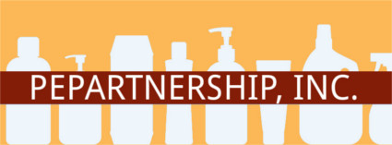

Pepartnership, Inc.

helping with the essentials of personal and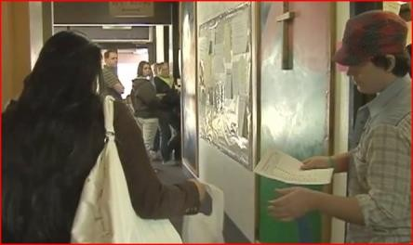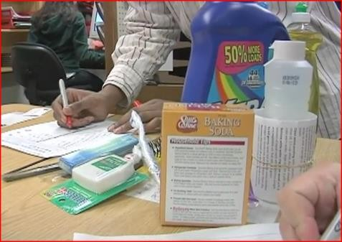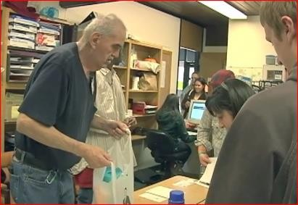 household hygiene

